Meeting Scheduling Software System

Document : Requirements, Analysis and Design
Author : Peter Golaszewski
Updated : March 19, 2000
Course : WPI CS562 CD00

Table of Contents:

Domain Analysis – Use Cases 3
Application Requirements 4
Rapid Application Prototyping – Use Cases 5
Class Analysis – CRC Cards 8
Class Analysis – CRC Diagram 11
Class Design – Logical View 12
Class Design – Attributes and Methods 13

Domain Analysis – Use Cases

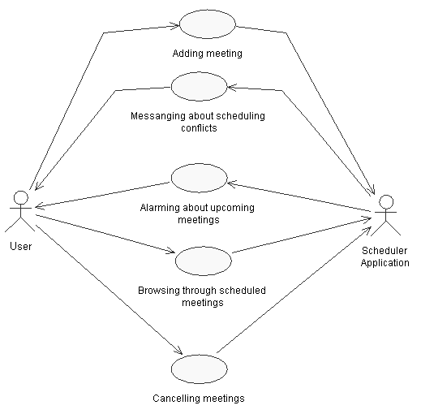

Application Requirements

- User must be able to add meetings using GUI.
- Each meeting has to have start date and time, end date and time, and the meeting description.
- Meeting description is a string of characters.
- Before adding a meeting to the schedule, the application must check for any time conflicts with other meetings and if a conflict is detected, it must alarm the user and abort the adding operation.
- User needs ability to add meetings that are reoccurring (e.g. “Every day 12:30 pm – 4:00 pm).
- User needs to be alarmed about upcoming meetings ahead of time.
- User needs ability to browse the schedule back and forth (e.g. jump to view one week ahead, one month ahead, etc).
- User needs to be able to view the description of any scheduled meeting.
- Application must provide the user with ability to cancel any meeting.

Rapid Application Prototyping – Use Cases

The scheduler application begins with following window:

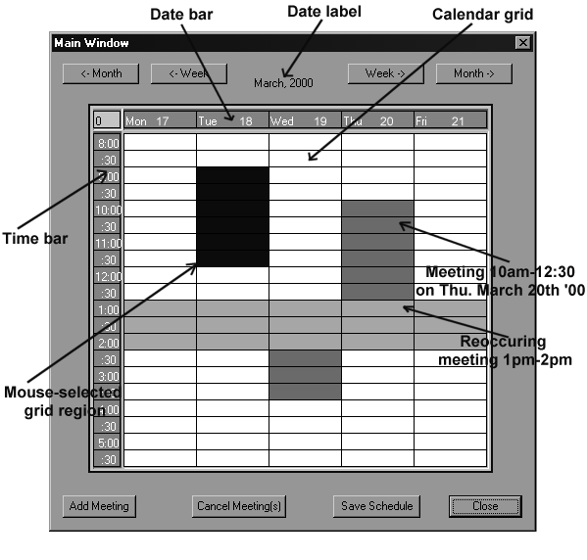

1. User can add a meeting to the schedule by first selecting the grid-region that corresponds to the meeting time-frame and then clicking on the ‘Add Meeting’ button. That’s when following window would appear:

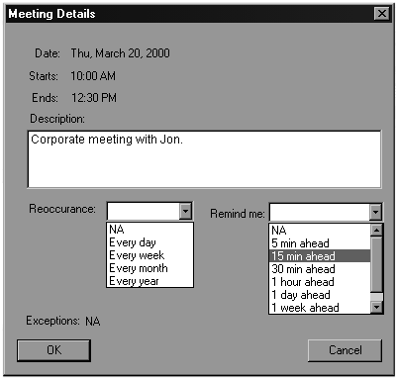

After entering the meeting information, the user would click on the ‘OK’ button. If there are no time conflicts, the scheduler would add the meeting to the schedule. To add an all-day meeting, user could click on one of the cells on the date bar and then follow similar procedure. In order to add a reoccurring meeting, the user would select a time region directly on the time bar.

2. To view details of a previously entered meeting, the user would double-click on one of the shaded calendar cells. The ‘Meeting Details’ window would then appear, showing the information to the user. At this point, the user would have ability to modify the description of the meeting as well as its reoccurrence and reminder specifications. Clicking on the ‘Cancel’ button would not cause any changes to the schedule.

3. If the user clicks on one of the navigational buttons at the top of the main window, the calendar grid will be updated to show the corresponding week. The date label might also be changed if the user navigated into a different month.
4. When it’s time to remind the user about a meeting, following window will appear:

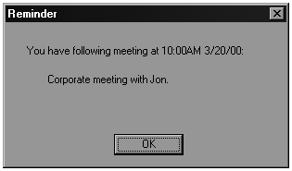

5. User will have ability to save changes to the schedule. This way when the application is reopened, the last saved meetings schedule will be brought up. In order to save the schedule, user will click on the ‘Save Schedule’ button. When the saving process is complete, the application will display a simple message window for the user.

6. In order to cancel meetings the user will do following: First, the user will have to select the time to be freed up. If the user wants to cancel a meeting, any grid cell belonging to that meeting can be selected. If the user wants so free up a time range between say 11 am and 3 pm on Thursday March 20th 2000, then that exact time range should be selected. If the user wants to free up entire day from any meetings, the selection can be made directly on the date bar. Once the selection is been marked, the user will click on the ‘Cancel Meeting(s)’ button. Following dialog box will then appear:

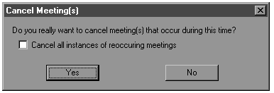

If the user leaves the checkbox unchecked, just the selected instances of a reoccurring meetings will be cancelled. In other words, a reoccurring meeting will still be scheduled but an exception date will be marked and the time space occupied by an instance of the meeting will be freed (see the Meeting Details windows above). If the user checks the checkbox, all reoccurring instances of selected meetings will be canceled.

Class Analysis – CRC Cards

Class: Scheduler
Stereotype: GUI application
Super-class: MeetingListener
Responsibilities | Collaborations
Displays the GUI representation of the schedule for a particular week | TableBean  MeetingBean  Meeting
Allows the user to browse through the schedule back and forth | TableBeen  MeetingBean
Keeps track of date and time selections made by the user | TableBean  Meeting  MeetingDate
Lets the user view the details of a previously scheduled meeting | Meeting  MeetingDate  MeetingDetailDialog  MeetingBean
Lets the user modify the details of a previously scheduled meeting | Meeting  MeetingDate  MeetingDetailDialog  MeetingBean
Lets the user cancel one or more meetings within a specified time frame | MeetingDate  DeleteOptionsDialog  MeetingBean
Lets the user save current meeting schedule to the disk and then retrieves the save schedule on the next application run. | MeetingBean
Alarms the user with a message box if a meeting reminder time is up | MeetingBean

Class: MeetingBean
Stereotype:
Super-class:
Responsibilities | Collaborations
Keeps the list of currently scheduled meetings | Meeting
Allows for addition of new meetings | Meeting  MeetingDate
Allows for retrieval of existing meetings that are scheduled on a particular day | Meeting  MeetingDate
Allows for deletion of existing meetings that are in conflict with another meeting specified by the third party | Meeting
Allows for deletion of a single existing meeting | Meeting
Allows for specifications update of a single existing meeting | Meeting
Checks for time conflicts between all scheduled meetings | MeetingDate
Can be serialized | MeetingDate
Alarms a third-party component when a reminder time is up | Meeting  MeetingDate  MeetingListener

Interface: MeetingListener
Stereotype:
Super-class:
Responsibilities | Collaborations
Performs an action when notified about an upcoming meeting | Meeting

Class: Meeting
Stereotype:
Super-class:
Responsibilities | Collaborations
Stores and manages all the meeting-related information such as start date+time, end date+time, description, reoccurrence, reminder time, list of date exceptions. | MeetingDate
Allows for modification of all the meeting-related information. | MeetingDate
Checks if it runs into scheduling conflicts with another meeting.

Class: MeetingDate
Stereotype:
Super-class: java.util.Calendar
Responsibilities | Collaborations
Keeps track of a particular date and time, down to minutes | Calendar
Allows for modification and retrieval of the date and time parameters | Calendar
Can be set to current time | Calendar
Can be transformed into a single string with accuracy down to minutes
Returns new MeetingDate instance that is given number of hours or days ahead or past. | Calendar
Checks if itself is contained between two other instances of MeetingDate. | Calendar

Class: MeetingDetailDialog
Stereotype: dialog window
Super-class:
Responsibilities | Collaborations
Provides GUI for viewing and modifying an instance of a meeting (see Rapid Application Prototyping – Use Cases) | Meeting, Meeting Date

Class: DeleteOptionsDialog
Stereotype: dialog window
Super-class:
Responsibilities | Collaborations
Provides GUI meeting cancellation options (see Rapid Application Prototyping – Use Cases)

Class: TableBean
Stereotype:
Super-class:
Responsibilities | Collaborations
Provides GUI for displaying a grid of custom dimensions, content, background color, etc.
(see http://www.cs.wpi.edu/~heineman/classes/cs562/E2/gui/TableBeanBeanInfo.java)

Class Analysis – CRC Diagram

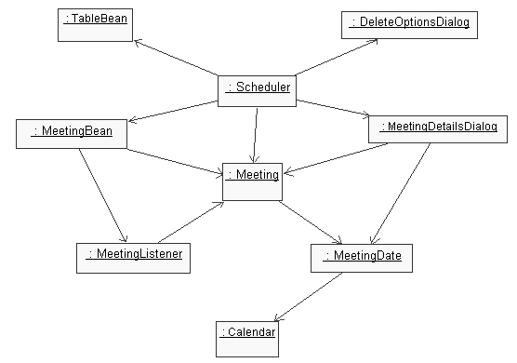

Class Design – Logical View

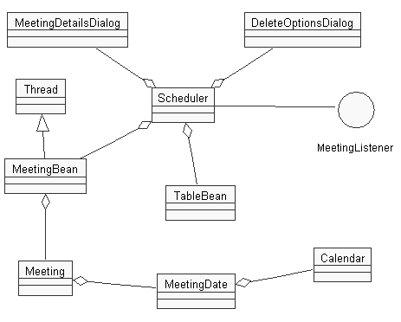

Class Design – Attributes and Methods

